**Artefacts from Sprints 1 & 2**

**1. First Sprint and Release Plan Draft**

Wrote the first draft of the user stories for the scrum. These stories were mostly based on notes compiled from team meetings, the remaining were created from scratch in this document. They are currently in a very incomplete state. The highlighted areas show points of uncertainty meant to be discussed with the group. The first attempt to identify the client types was also in this document.

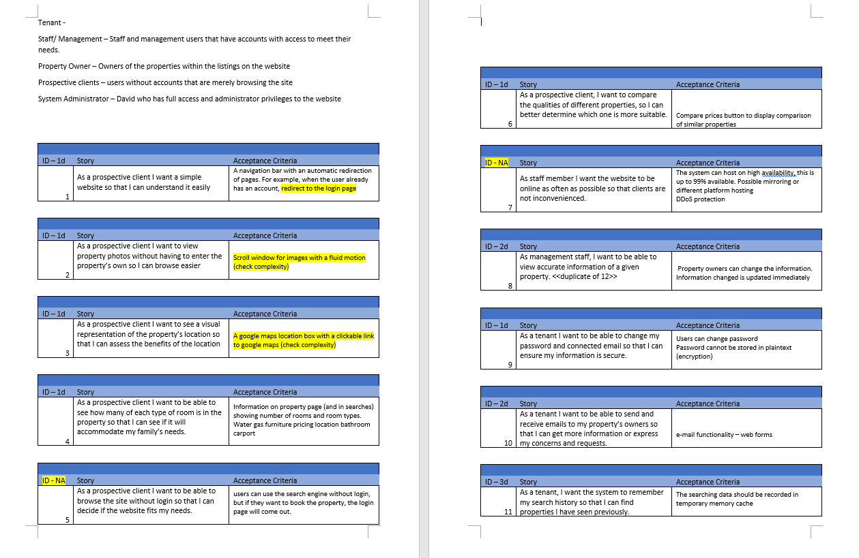

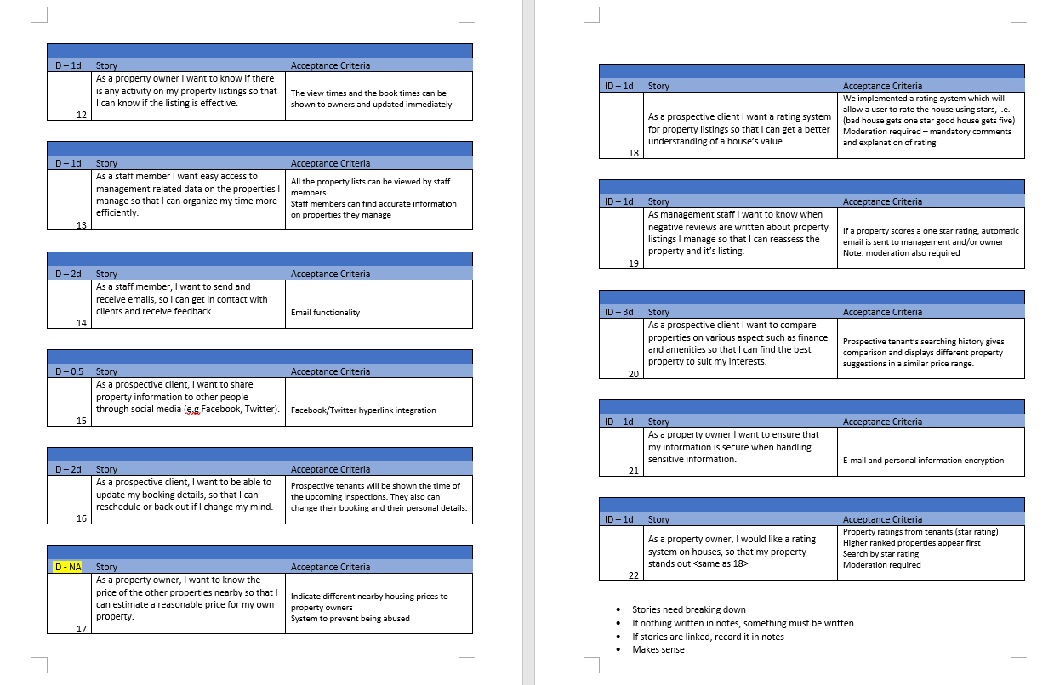

**2. Final Version of Stories 9 through 13**

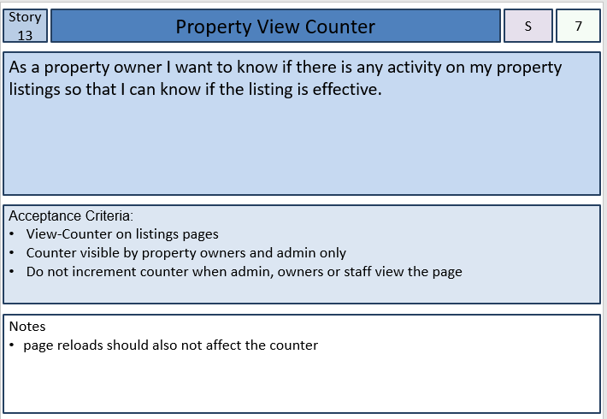Completed the final versions of the stories numbered 9 through to 13. The final versions were based on earlier draft stories originally designed during team meetings. The final versions were modified to use the correct format for a story plan and were more fleshed out. Prior to this version the acceptance criteria sections consisted of short incomplete notes on what feature the stories were describing.

|  |  |
| --- | --- |
|  |  |
|  |  |

**3. Compiled Sprint Burn-down chart of release 1**

This sprint Burn-Down Chart was created to reflect the team’s desired progress and actual progress after release 1. The rigid shape of the team’s actual progress comes from the members of the development team only submitting results when entire sections were completed. This chart shows a clear trend of the development being behind schedule.

**4. Final Arrangement of Sprint Plan 1**

Organised and submitted the final Release Plan of Release 1. The Story Point estimations were thought of by the members of the development team. With the given estimations and the arrangements of previous drafts the final arrangements were designated to best fit the goals of the sprints and to best balance out workloads. Also, some story point estimations were changed in the final version. Once these changes were finalised and the rest of the group gave it their approval it was prepared for submission.

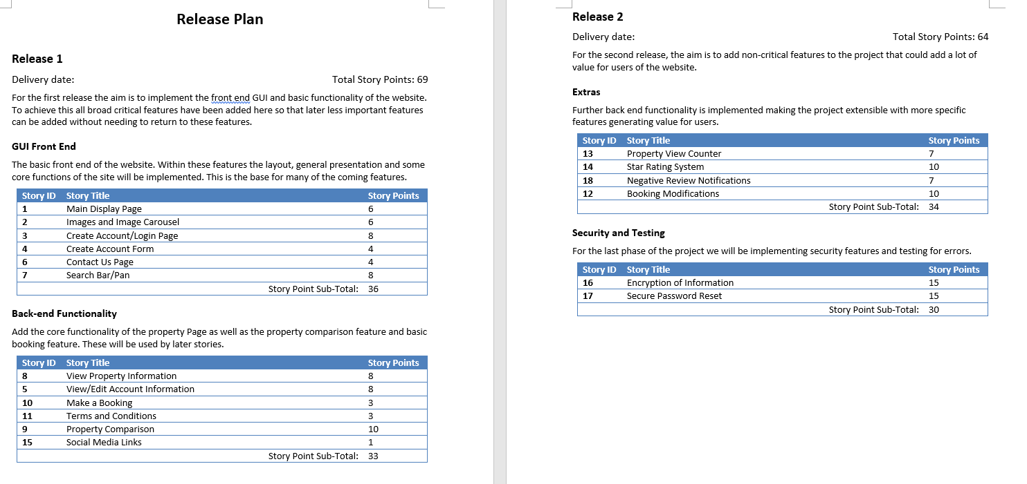

**Artefacts from the Product**

**5. Image Slider**

Below is the working Image slider, it was implemented using a mixture of JavaScript and HTML. When either of the arrow buttons are pressed the slider navigates to the next (right button pressed) or previous (left button pressed) image in the slider class and wraps around if the first or last is reached.

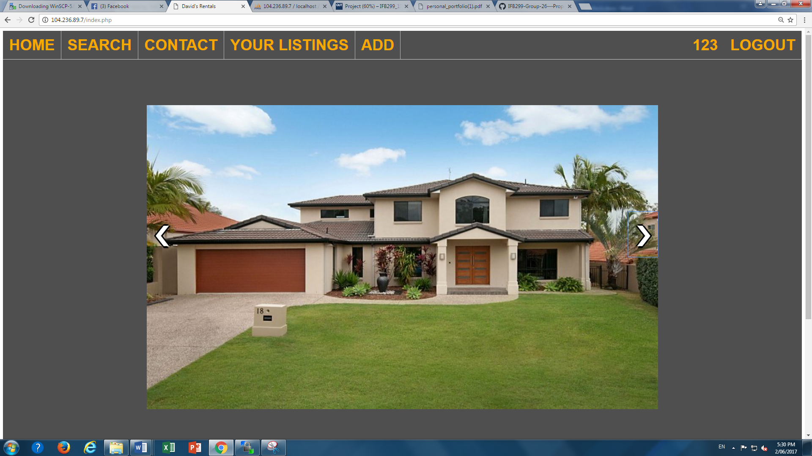

The HTML implementation of the Image Slider.

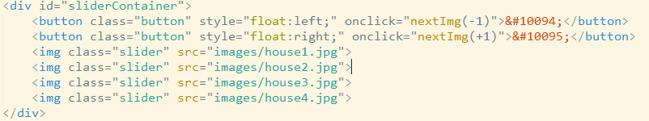

The JavaScript which allows the slider to function. The *nextImg* function calls the *dispIng* function while incrementing to the next or previous index. The *dispIng* function checks if the first or last is reached, removes the old image from the page and then adds the new indexed image to the view.

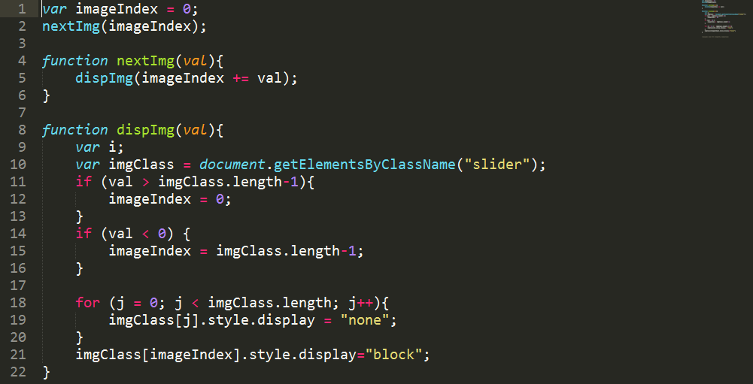

**6. CSS**

Most of the CSS was written early on with only a few positional divs being defined later on. Within the group no members had any substantial skill in CSS so the job was given to the first to concede, as such the visual aspects of the CSS could be said to be lacking. A few features of the CSS were made by other members of the group but the overall styling was created and implemented by myself.

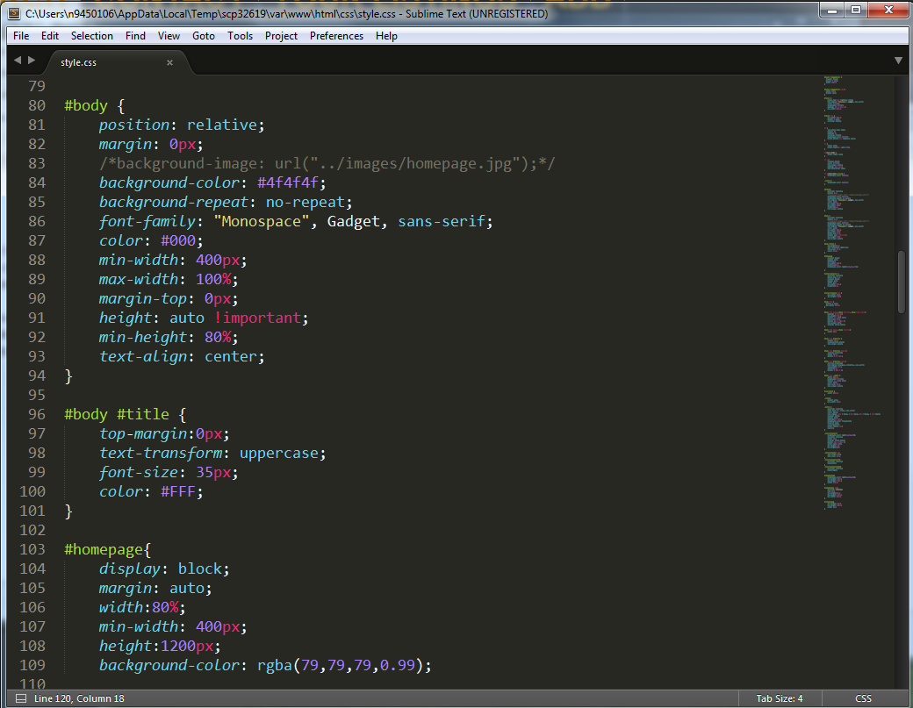

**7. Property Listings**

The property listings are generated based on the listings found in the PHP database. When a logged in user navigates to the listing page every lasting owned by that user will be displayed, if a user has issued a booking it will appear as text on the listing.

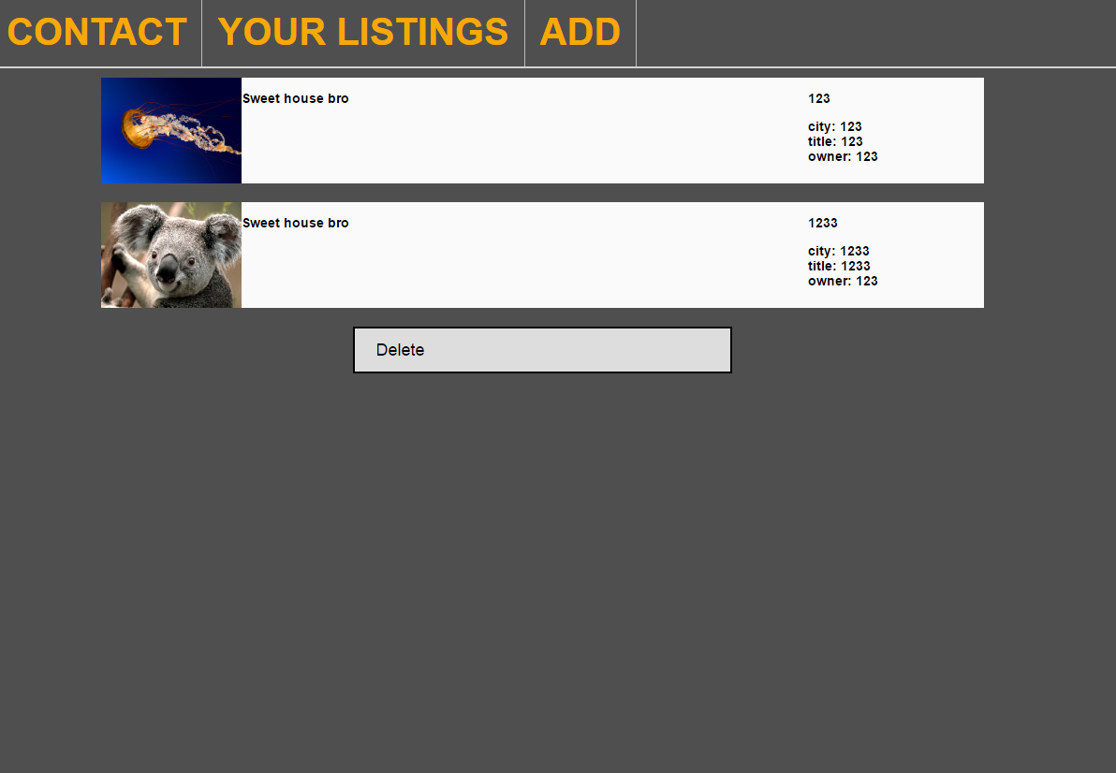

The code which generates each listing from the data gathered by queries. The listings are generated by echoing the code to create a single listing within in a for loop and iterating through the different values of each listing.

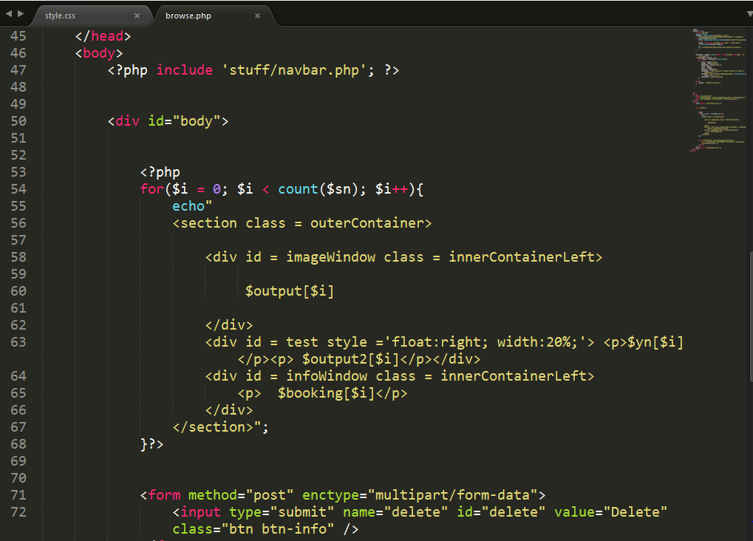

The code which grabs the listing data from the database. The database is accessed using an SQLI based implementation.

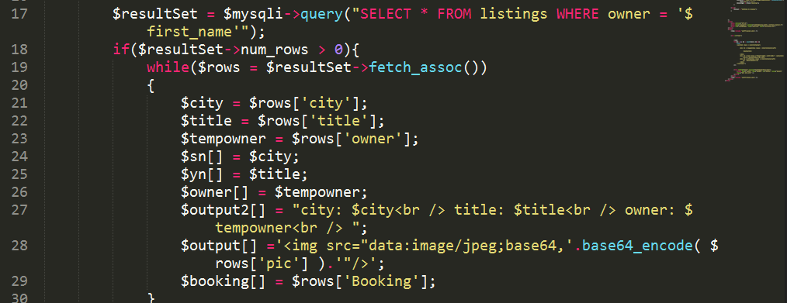

**8. Final Business Letter**

The final edited version of the business letter. The business letter was handled by three team members, the first being the only remaining member of the client team. Unfortunately due to language barriers this member needed assistance writing with the English language and as such his version was heavily edited to better convey his intentions. From there I further changed the business letter to fit the specifications and added some points I otherwise felt needed to be included. After reading this version no group member felt the need to change the letter further and it was submitted.

